[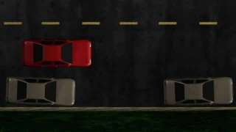](http://www.driversedguru.com/wp-content/gallery/stef-images/parallel_parking_1.jpg)1η Φάση

[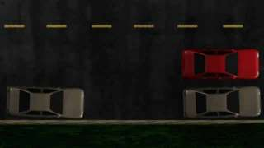](http://www.driversedguru.com/wp-content/gallery/stef-images/parallel_parking_2.jpg)

2η Φάση

[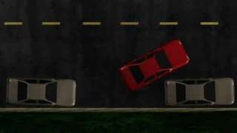](http://www.driversedguru.com/wp-content/gallery/stef-images/parallel_parking_3.jpg)

3η Φάση

[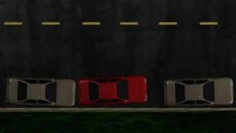](http://www.driversedguru.com/wp-content/gallery/stef-images/parallel_parking_4.jpg)

4η Φάση

[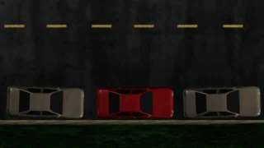](http://www.driversedguru.com/wp-content/gallery/stef-images/parallel_parking_5.jpg)

5η Φάση